****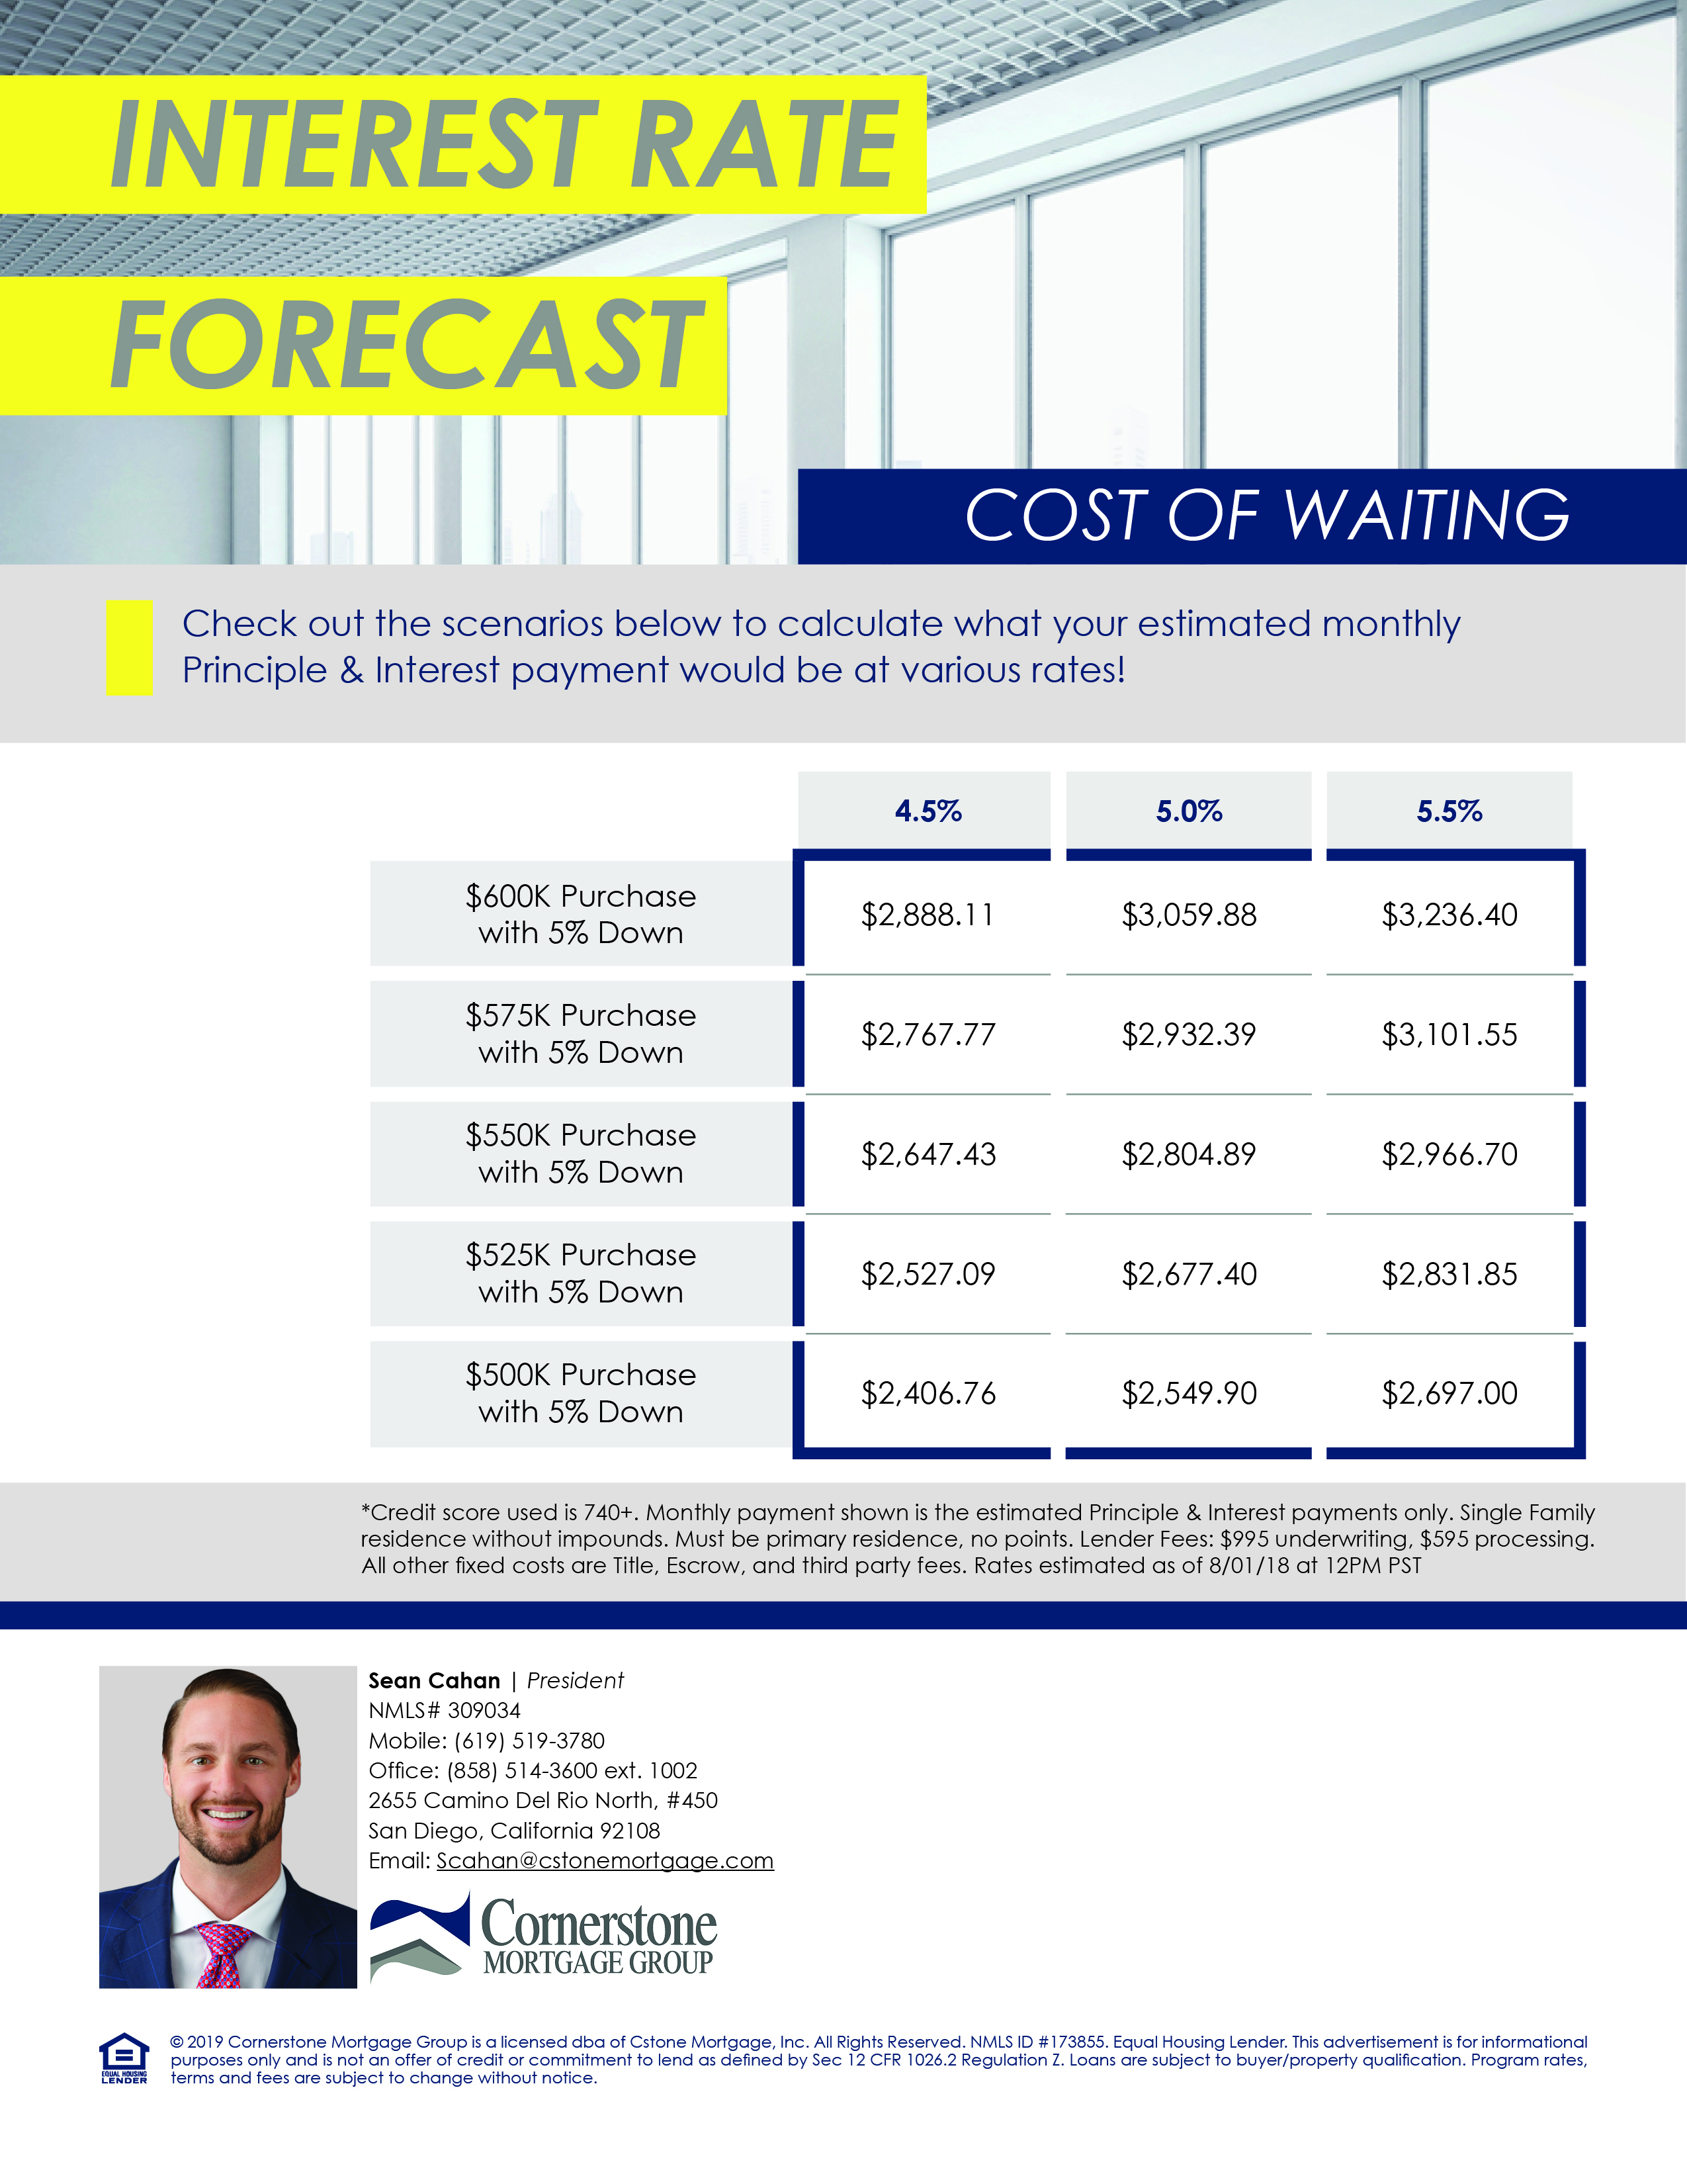

**Realtor Name**

*Job Title*

NMLS# XXXXXX | BRE#: XXXXXXX

Mobile: XXX.XXX.XXXX

Office: XXX.XXX.XXXX Ext. XXXX

Fax: XXX.XXX.XXXX

Email: yourname@companyname.com